Date: 2/4/2026
Start Time: 9:30 pm
End Time: 12:30 am
Challenges / Roadblocks: What I found to be the most difficult was the last flag to not get denied from the IDS which took some research into how to work around IDS/IPS rules.
Total number of flags: 9/9
Flag 1: Windows, based on the TTL 128 provided which indicates a windows machine.

Flag 2: 7, used a general nmap scan command to find the open tcp ports that were listed.
Flag 3: NIX-NMAP-DEFAULT, took a more aggressive approach that took longer than expected to scan everything in a more less stealthy way, which if you tried to do something undetected would not be the best command but is more accurate to obtain information on a host such as the OS and hostname.
Flag 4: 31337, having the scan download an .xml file with -oX, and then converted the .xml file to an html file to be readable most beneficial for documentation when giving a pen test report.
Flag 5: HTB{pr0F7pDv3r510nb4nn3r}, used port 31337 which was open and netcat to extract the header to get the flag.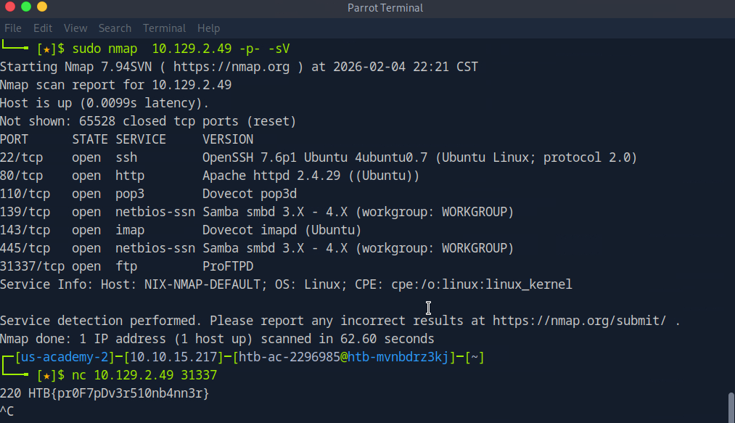
Flag 6: HTB{873nniuc71bu6usbs1i96as6dsv26}, port 80 was open and was able to obtain a file in the sever using wget to download the file to the instance and cat command to open it and get the flag.
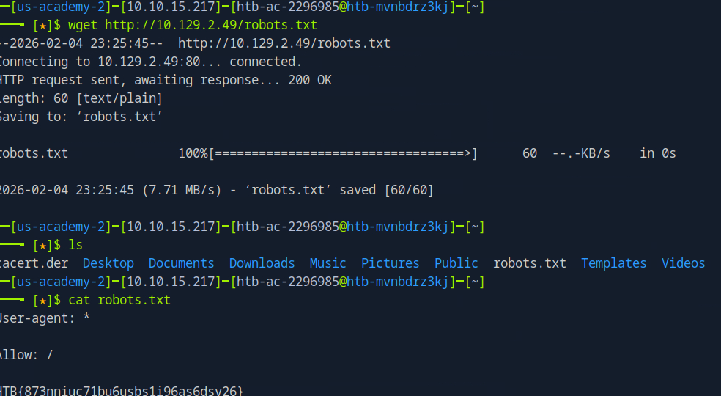
Flag 7: Ubuntu, from using the obtain OS command with a stealthier -T 3 approach to not set off the IDS/IPS. Which takes longer but will look like normal flow of traffic instead of scanning the network or port.
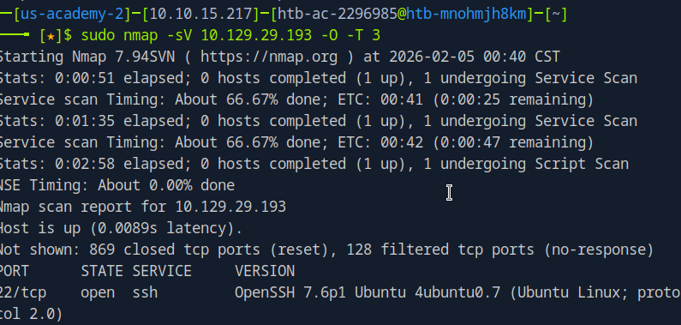

Flag 8: HTB{GoTtgUnyze9Psw4vGjcuMpHRp}, did a regular nmap scan with the IP provided, with sending UPD packets, spoofing the port that it was coming from, and using Pn to force nmap to scan the IP.
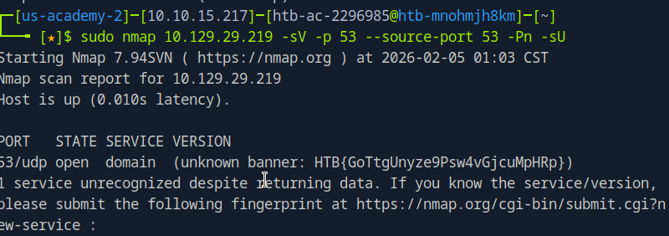

Flag 9: HTB{kjnsdf2n982n1827eh76238s98di1w6}, used an nmap scan using -sS so it does not make a full connection, -Pn to skip host discovery, and making the source port come from 53 because it can pass IDS/IPS detection looking like essential traffic. Performed a -sV scan on port 50000. Then used ncat to get the banner to get the flag.
